LOAVES AND FISHES MINISTRY PRESENTS

THE EDWINA BEALL SCHOLARSHIP
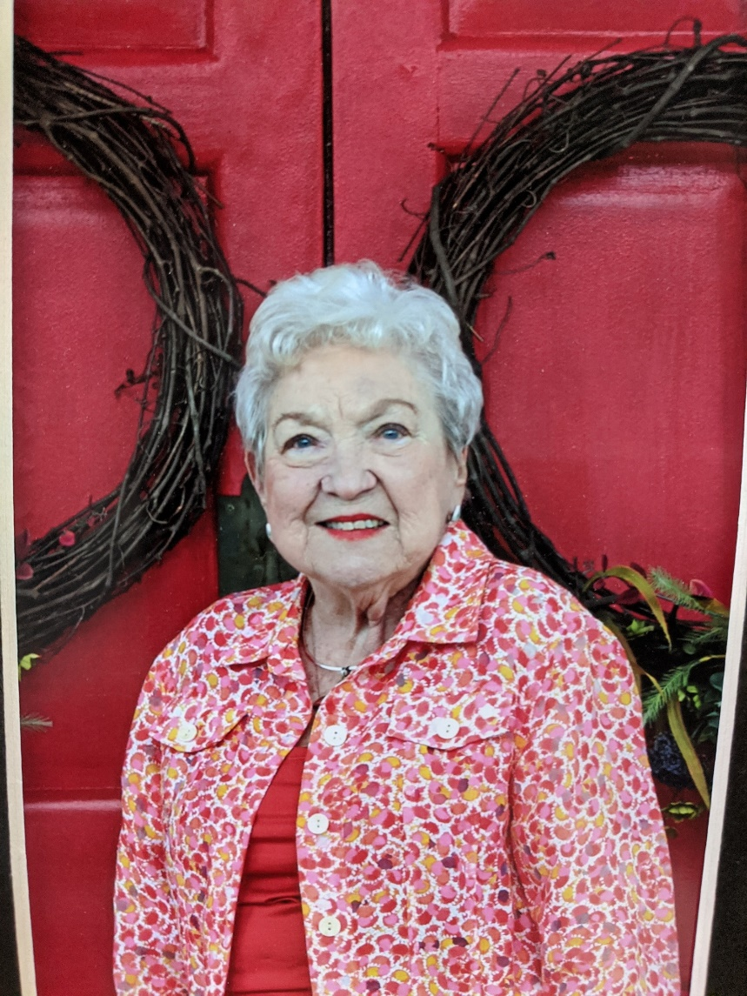

LOAVES AND FISHES MINISTRY
651 MARTIN LUTHER KING, JR. BLVD
MACON, GEORGIA 31201

IMPORTANT INFORMATION
- Students are ineligible to receive the scholarship if required documentation is not received by the designated date. Required documentation must be mailed or hand-delivered to the Loaves and Fishes Ministry.
- First-time applicants must attend an initial interview to be considered for scholarship that academic year
- Entering Freshmen only need to submit an official copy of high school transcript, proof of registration at postsecondary school or a Technical School/Community College and have full time status
- Required Documentation: (A copy of current transcript and proof of registration) must be submitted to the Loaves and Fishes Scholarship Committee by designated date. Following the receipt/review of documentation and interview process scholarships will be awarded.
- Interested students may contact a Loaves and Fishes Scholarship Committee member prior to each semester for upcoming interview dates.
Eligibility for the Loaves and Fishes Ministry Scholarship
Step I
- Candidate must be a student of Bibb County Schools (Public/Private)
- Candidate must be a family/extended family member of a Loaves and Fishes client (Child, grandchild, great-grandchild, niece, nephew)
- Candidate must currently have at least a 3.0 GRADE POINT AVERAGE
- Candidate must be planning to attend a post-secondary institution or a Technical School/Community College
- Candidate must complete the Loaves and Fishes Application and submit by published deadline date
- Candidate must include a copy of their High School Transcript
- Candidate must attend an initial scholarship interview in person
- Candidate must commit to 15 hours of volunteer hours per school year at Loaves and Fishes Ministry
Step II
- A reoccurring scholarship candidate must provide a copy of current transcript and proof of registration each grading period showing cumulative Grade Point Average for term
- For Freshmen Only: Candidate must submit proof of registration for quarter/semester and show proof of full-time status
Loaves and Fishes Scholarship Committee
Northminster Church Representative
Cornerstone Church Representative
Greater Bellevue Church Representative

Email: actsofkindness5417@gmail.com

Loaves and Fishes Scholarship Mission
The Loaves and Fishes scholarship exists to inspire students learning from within the community of our clients' family/extended family members and to inspire the attitude of service. Our aim is to give back to those who are lost, left out, and left behind in our surrounding community. The Loaves and Fishes Scholarship Committee is strongly committed to quality education and success by providing incentive to our students with scholarships and direction in their college career.

THE EDWINA BEALL SCHOLARSHIP
APPLICATION

THE EDWINA BEALL SCHOLARSHIP
Edwina Beall was born in Ft. Lauderdale, Florida. She graduated from high school in Ft Pierce, Florida. She then graduated from Wesleyan with a Bachelor’s degree at a time when less than 5% of women attended college. She was married to her husband Dennis for 53 years until his death in 2007. Edwina had two daughters, Denise Fritze and Margaret Cohen. Edwina is very active with The Daughters of the American Revolution and has served on many local and state boards. She presents the DAR Good Citizen award each year to both public and private school seniors in Bibb County. She is also involved with many other organizations dealing with the preservation of history. Edwina, a member of St. Andrews Presbyterian Church, attended a joint Thanksgiving worship service at Mt. Zion Baptist Church. She lost her footing and fell and hit her head so hard she lost consciousness. She was rushed to the hospital where she was declared dead. Well, God had other plans for Edwina, and she did not die. When she regained consciousness, she decided God was not ready for her yet and she was going to devote herself to a community ministry...so glad she chose Loaves and Fishes!
ELIGIBILITY
- Candidate must be a student of Bibb County Schools (Public/Private)
- Candidate must currently have at least a 3.0 GRADE POINT AVERAGE
- Candidate must be planning to attend a post-secondary institution or a Technical School/Community College
- Candidate must be a family/extended family member of a Loaves and Fishes client-friend (child, grandchild, great-grandchild, niece, nephew)
- Candidate must commit to 15 hours of volunteer hours per school year at Loaves and Fishes Ministry
PROCEDURE
- Attached application must be submitted to the Loaves and Fishes Ministry by May 10, 2023.
- One letter of recommendation (from other than relatives) must be submitted along with the application by the due date listed above. (Note: The letter should speak to the character, integrity and or uniqueness of the applicant.)
- Applicants must attach a copy of their High School Transcript to their application
- Applicants will be interviewed by the selection committee by mid-May of 2023.
- The scholarship will be presented to the recipient at the Loaves and Fishes Board Meeting in early June of 2023. The selected applicant will at that time read his/her essay during the Loaves and Fishes Board Meeting.
Loaves and Fishes Scholarship
THE EDWINA BEALL SCHOLARSHIP
Application
Due: May 10, 2023
Applicant Information
Name: | _______________________________  First | ________________________________  Last |  |  | ____________  Suffix
Home Address: | ______________________________  Street Number: | __________________  City: | ______  State: | ________________  Zip:
Mailing Address  (if different from Home Address) | _____________________________  P.O. Box | __________________  City: | ______  State: | ________________  Zip:
Contact: | _______________________________  Email: | (________)________________  Home: |  | (_______)_____________  Cell:
Parent Information
Parent(s)/  Guardian(s) Information | _______________________________  Full Name: | ___________________________  Relationship to Recipient |  | (_______)_____________  Phone: (Optional)
 | _______________________________  Full Name: | ___________________________  Relationship to Recipient |  | (_______)_____________  Phone: (Optional)
Education Information
__________________________________________________  Name of High School: |  | ____________________  Current GPA: |  | Standard Advanced GED  Type of Diploma (Circle)
Clubs, Activities, Community Involvement:
____________________________________________________________________  College Plan to Attend: |  |  | Yes No  Accepted? (Circle)  If yes, please include an acceptance letter.

Your Submission
Please answer the following on separate paper, with your name on top. (Must be typed)
Write a brief essay of 350 to 500 words on:

“What would you do to fight hunger, homelessness and poverty in the Macon-Bibb County Community”

Note: Please feel free to include any new ordinances/laws, policies or changes to current ones that would need to be put into place to implement your ideas.

Describe any job experience(s) you have had and how they have prepared you for your next step in life.

------------------------------------------------------------------------------------------------------------------------------------------------------

CERTIFICATION

I certify that all the statements made in this form are true, complete and correct to the best of my knowledge and belief and are made in good faith.

Print name: _________________________________ Date: ________________
Applicant Signature: ____________________________________

School Counselor:
I have reviewed the applicant’s responses and certify that they are correct, insofar as the official school records indicate.

________________________ ____________________________ _________
Print Name Signature Date

